**Shashwat Tripathi**

**D10A 58**

**Batch: C**

**PYTHON LAB**

**Exp No: 1**

**AIM:** Write python programs to understand

a) Basic data types, Operators, expressions and Input Output Statements

b) Control flow statements: Conditional statements (if, if...else, nested if)

c) Looping in Python (while loop, for loop, nested loops)

d) Iterators and Generators.

**PRINT STATEMENT**

Code:

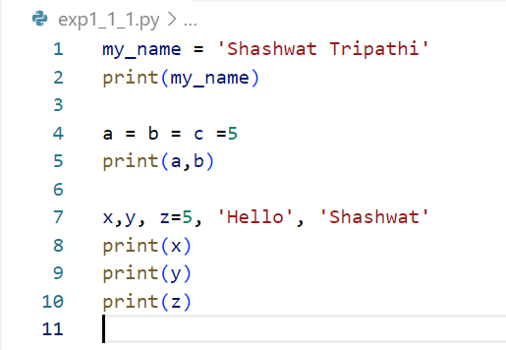

Output:

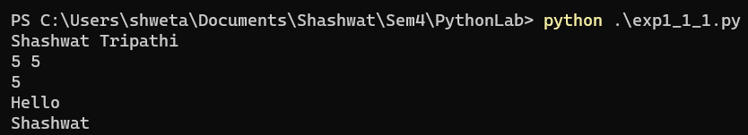

**IDENTIFY TYPES**

Code:

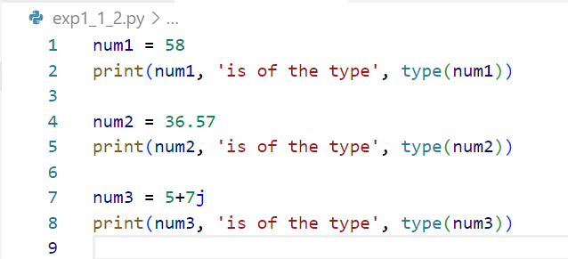

Output:

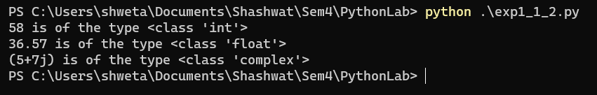

**PRINT DATA OF TYPES**

Code:

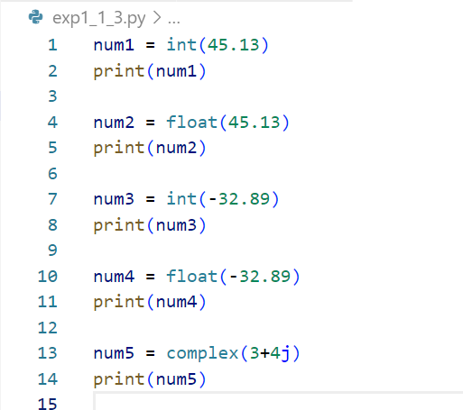

Output:

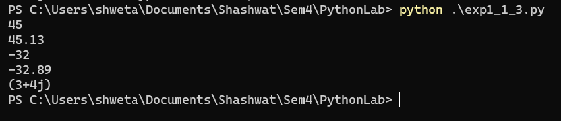

**ADDITION OF TWO NUMBERS**

Code:

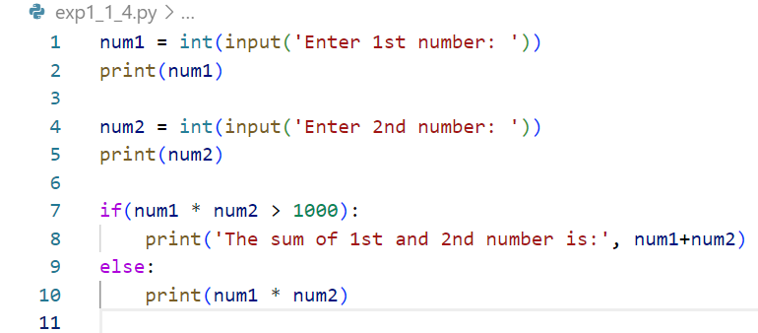

Output:

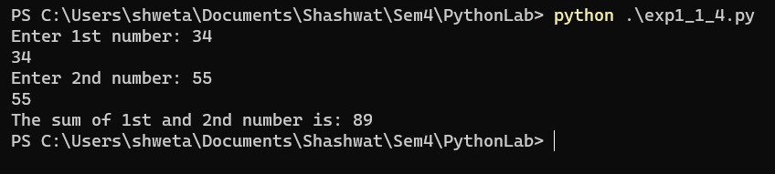

**DATA FROM USER**

Code:

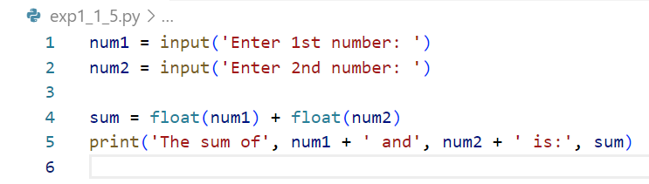

Output:

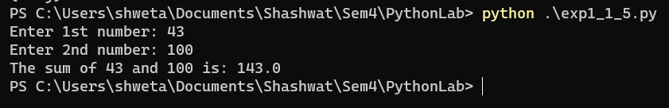

**ARITHMETIC OPERATORS**

Code:

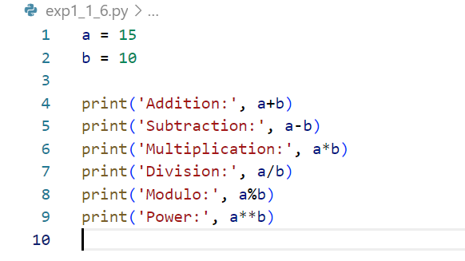

Output:

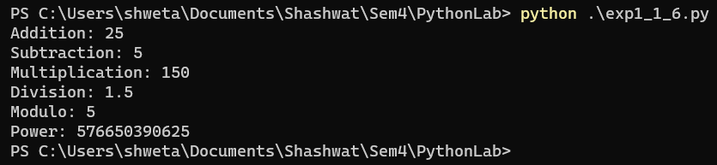

**ASSIGNMENT OPERATORS**

Code:

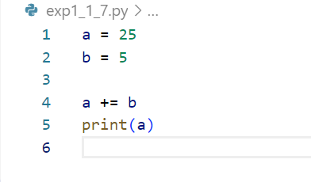

Output:



**COMPARISON OPERATORS**

Code:

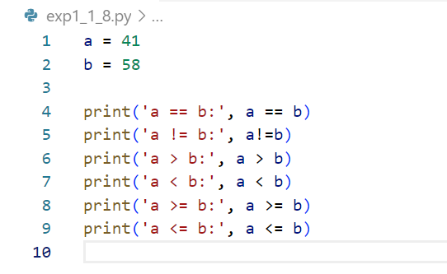

Output:

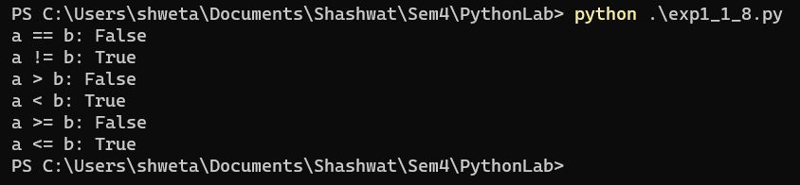

**IDENTITY OPERATOR**

Code:

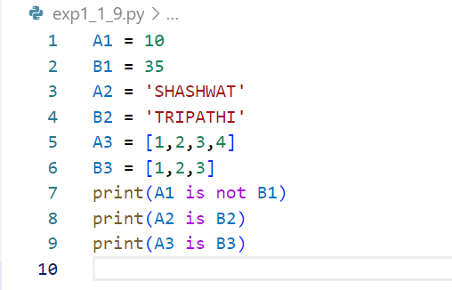

Output:

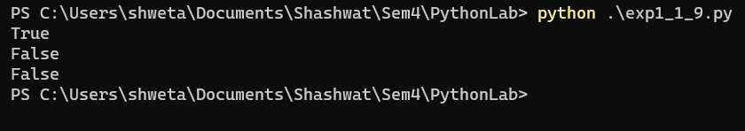

**MEMBERSHIP OPERATOR**

Code:

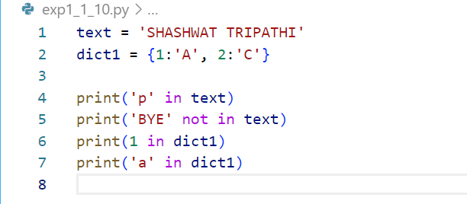

Output:

